
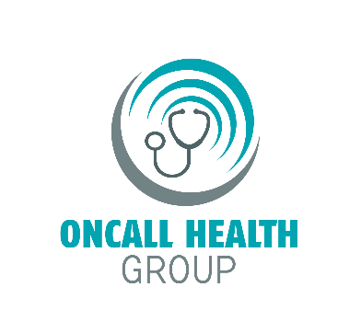

Dear ${CustomerFirstName} ${CustomerLastName},
Thank you for your purchase of ${MerchantCompanyName}, powered by GetLyric With ${MerchantCompanyName} you and your family will receive 24/7 access to US Board Certified Physicians.
Consultations are FREE and no insurance is needed. Prescriptions are sent directly to the local pharmacy of your choice when medically necessary. Use this service from home, work, and when you’re on vacation. Save time and money on unnecessary & expensive Emergency room or Urgent Care Visits. It’s just like having a Doctor in your pocket!
Use this program as much as you want during your ${trialDays}-day trial and after the trial ends, keep it for only only ${MonthlyPayments}, and will be billed on the ${NextBillDate} of each month. Your Account will read as ${Descriptor}. Since this plan is month-to-month you can cancel at any time and we will simply discontinue billing you.
For billing inquires or general questions regarding your benefits please call ${MerchantPhone} or you can visit ${Fulfillment}. Member Service hours of operation: Monday through Friday 9 am to 9 pm EST, Saturday and Sunday 9 am to 5 pm EST.
To activate your account to receive 24/7 access to US Board Certified Physicians please visit https://portal.getlyric.com/ and click on Activate or call us at ${MerchantPhone} during customer service hours.
For more information on your Healthcare benefit please read the following page
We look forward to serving your health care needs!
Sincerely,
${MerchantCompanyName}

Member ID# ${OrderNumber}

${MerchantPhone}
${MerchantCompanyName}
5337 N Socrum Loop Road
Unit 406 Lakeland, FL 33809
${MerchantCompanyName}
5337 N. Socrum Loop Road Unit 406
Lakeland, FL 33809

${CustomerFirstName} ${CustomerLastName}
${Address}
${City}, ${State} ${ZipCode}

${MerchantPhone}
https://getlyric.com

